CS 255 System Design Document Template

UML Diagrams

UML Use Case Diagram
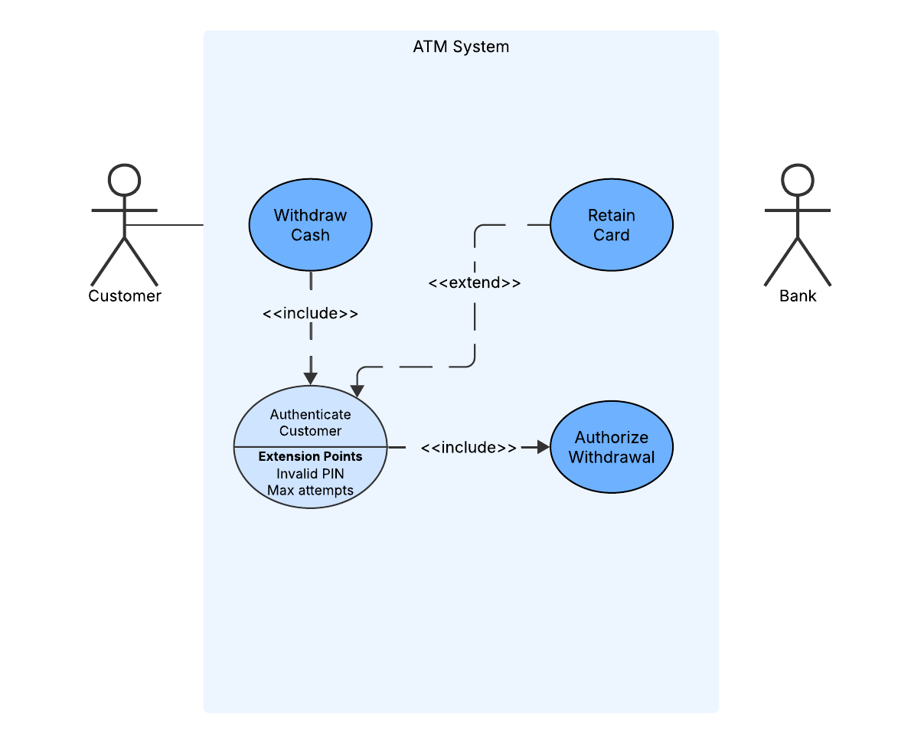

UML Activity Diagram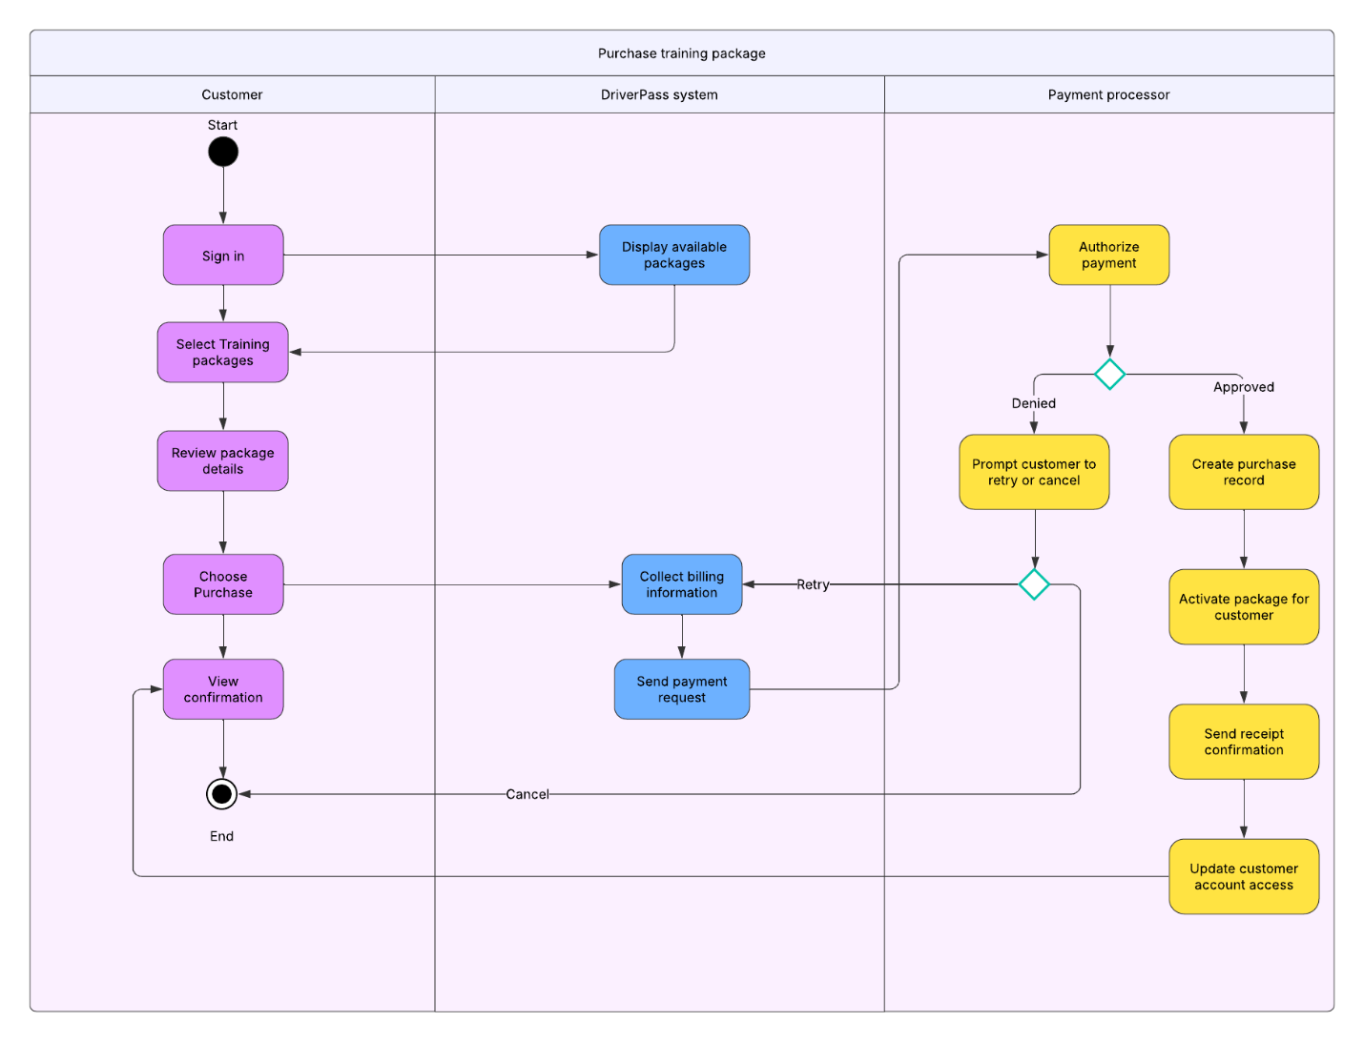
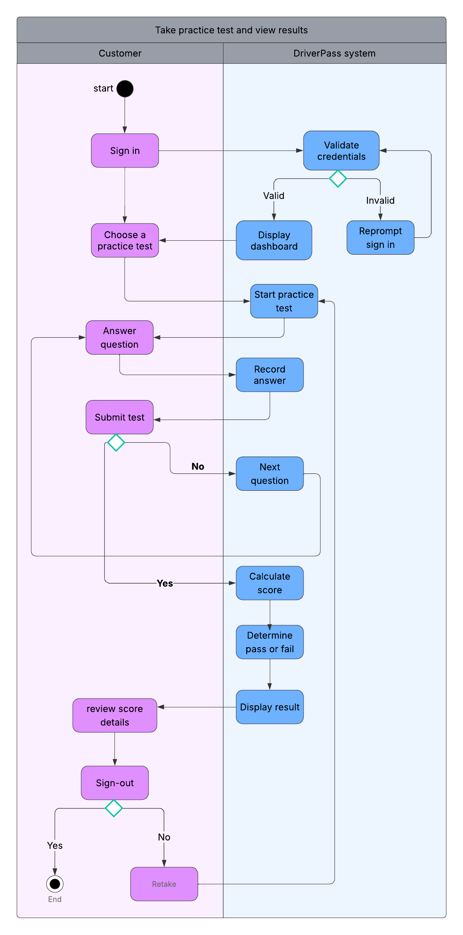

UML Sequence Diagram
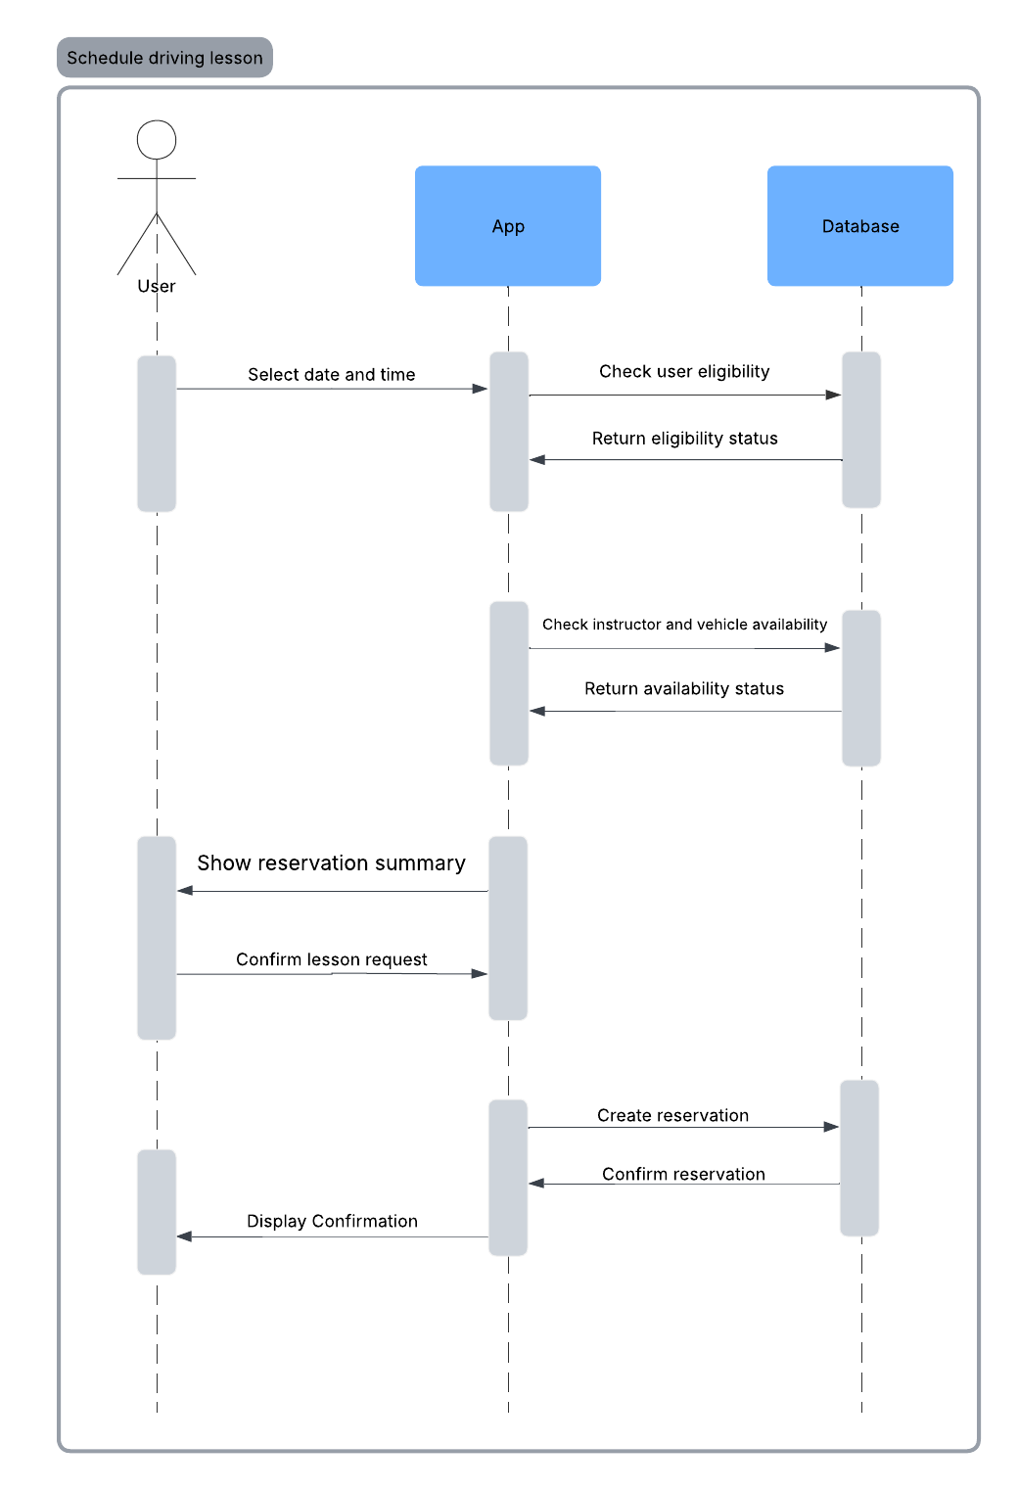

UML Class Diagram
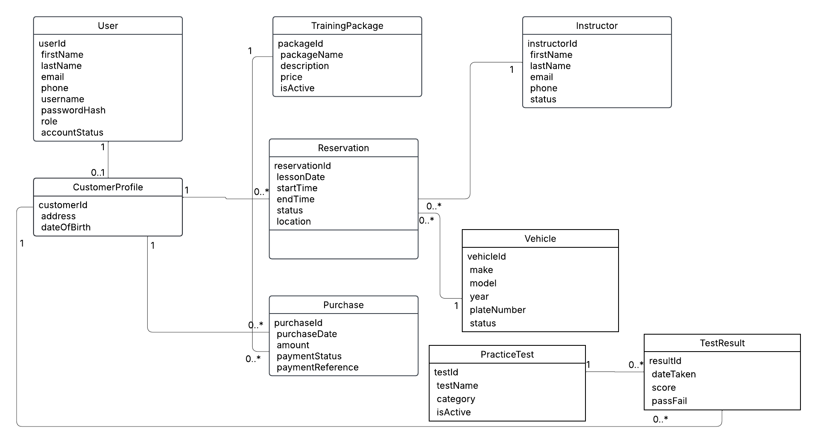

Technical Requirements

Technical Requirements
The DriverPass system must support online learning, lesson scheduling, and secure account management for students, instructors, and administrative staff. To meet the functional and nonfunctional requirements identified in Project One, the system requires the following hardware, software, tools, and infrastructure.

Hardware Requirements
The DriverPass system will be hosted in a cloud based environment to support availability, scalability, and remote access. End users will access the system using standard consumer devices such as desktop computers, laptops, tablets, and smartphones. No specialized hardware is required for customers beyond an internet capable device and modern web browser. Server infrastructure must support concurrent users, secure data storage, and routine backups. Cloud hosted servers will allow the system to scale based on usage, particularly during high traffic periods such as exam preparation or peak scheduling times.

Software Requirements
The system will be implemented as a web based application using a modern web application framework. The application must support role based access for customers, instructors, staff, and administrators. Secure authentication and authorization mechanisms are required to protect user accounts and sensitive information. A relational database management system will be used to store user accounts, customer profiles, training packages, purchases, reservations, practice tests, and test results. The database must support transactional consistency to ensure reservations, payments, and test results are stored accurately. The system must integrate with a third party payment processor to securely handle package purchases. Payment processing software must comply with industry security standards and must not store full payment card information within the DriverPass system.

Tools and Development Environment
A CASE tool such as Lucidchart is required for modeling and maintaining UML diagrams, including use case, activity, sequence, and class diagrams. These diagrams support communication between technical team members and stakeholders. Version control tools will be used during development to manage source code and track changes. Development and testing environments must be separated from the production environment to ensure system stability and data integrity.

Infrastructure and Security Requirements
The DriverPass system must be hosted on secure cloud infrastructure with encrypted communication using HTTPS. User passwords must be stored using secure hashing techniques. Role based access controls must ensure that users can only access features appropriate to their role. The system must support audit logging to record significant actions such as lesson scheduling, cancellations, account updates, and package purchases. This supports accountability and troubleshooting. Regular system backups are required to prevent data loss. The infrastructure must also support routine updates to practice test content, including updates required to reflect changes in DMV rules or testing standards.

Availability and Performance
The system must be available to users at all times except during scheduled maintenance. Cloud infrastructure should support high availability and fault tolerance. The system must respond to user actions, such as scheduling a lesson or submitting a practice test, within an acceptable time frame to ensure a positive user experience.

